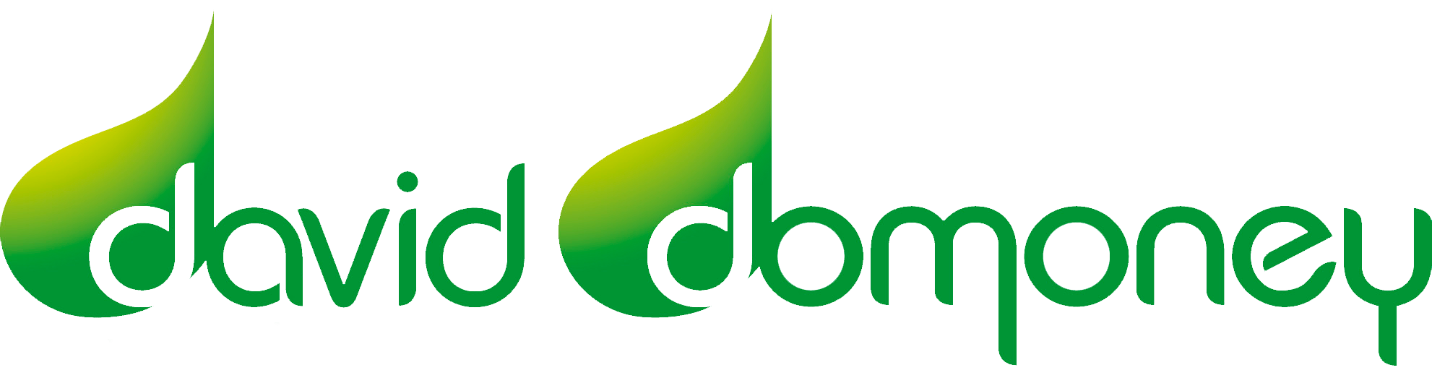PRIZE DRAW RULES – www.daviddomoney.com

Promoter
Domoney Ltd is registered with Data Protection Act and registered in England and Wales

ENTRY
daviddomoney.com is a UK based business and as such the Prize Draws are only open to UK based residents aged 18 or over.

For your entry to count you must subscribe to David Domoney’s – YouTube channel - https://www.youtube.com/user/domoneyltd/featured

Employees (and their immediate families) or associates of daviddomoney.com are ineligible from entering prize draws.

Closing dates are outlined in the post.

No purchase is necessary for Prize Draws. No cash alternative.

One entry allowed per person. Entries submitted on behalf of another person will not be accepted and joint submissions are not allowed. Incomplete, illegible, misdirected or late entries will not be accepted.

The Promoter does not accept responsibility for network, computer or software failures of any kind and has no responsibility for lost, delayed or misdirected entries.

The Promoter reserves the right to exclude any entries the Promoter in its sole discretion considers to be inappropriate, unrelated or offensive and to disqualify any entries if the Promoter, at its sole discretion, believes that there has been an attempt to manipulate or tamper with the operation of the promotion (including, without limitation, by setting up multiple email, Facebook or other social media accounts in order to submit multiple entries).

Each Prize Draw may be promoted on daviddomoney.com and also at events at which David Domoney or Domoney Ltd are participating.

By entering a prize draw entrants accept Domoney Ltd Privacy Policy.

PRIVACY POLICY
Your details
By entering the competition you have given your permission for www.daviddomoney.com to retain your details, which are held in the strictest confidence.
Your name and contact details information is held to enable us to maintain services to you and to communicate with you as necessary and as support for the service we provide to you.
We will, from time to time, contact you by email to offer our services and products.
We do not share your information with third parties and do not sell your information.

WINNERS
Winners will be chosen at random, from eligible entries, no later than the end of the month in which the closing date falls.

Winners will be notified through YouTube within 48 hours of the draw date. Winners should respond to the email notification so that arrangements can be made to receive the Prize.

Winners name and county will be published on www.daviddomoney.com after winners have acknowledged their Prize Draw win.

Prizes are not exchangeable or transferable.

The Promoter reserves the right to offer an alternative prize of equal or greater value. In the event of unforeseen circumstances or circumstances outside its reasonable control, the Promoter reserves the right to modify or discontinue, temporarily or permanently, this promotion without prior notice.

The promoter’s decision is final and no correspondence will be entered into.

UNCLAIMED WINNING PRIZES
If a prize winner does not acknowledge their win within 30 days then the prize will be considered null and void. The unclaimed prize may be used again at a later date.

PROMOTER
Domoney Ltd, 1c Atherstone Barns, 1st Floor Suite 2, Atherstone on Stour, CV37 8NE
Domoney Ltd is registered with Data Protection Act

These terms and conditions shall be governed by and construed exclusively in accordance with the laws of England and the parties agree to submit to the exclusive jurisdiction of the Courts of England.

YouTube Community Guidelines

Community Guidelines

YouTube is not a sponsor of this contest and require users to release YouTube from any and all liability related to your contest.

